Expertise in Cryptic Crosswords: An Exploratory Survey

Kathryn Friedlander¹ and Philip Fine¹

¹ Department of Psychology, University of Buckingham, UK

Background
Puzzles of all standards and for all ages, are routinely available in newspapers and magazines, and crazes for particular types of brainteasers – such as Sudoku – regularly sweep the world. One particularly long-lived puzzle type is the crossword, which exists in two basic forms: cryptic and non-cryptic. In the non-cryptic form, a clue word or phrase prompts the solver to discover a synonym word which will fit into the grid and intersect with cross-checking letters. This type of crossword is found throughout the world, and is the main (virtually the only) type of crossword to be found in the USA.
The focus of this study, however, is the ‘cryptic’ crossword, which may be found in broadsheet newspapers and quality magazines throughout the UK and Commonwealth. In these puzzles, the surface reading of the clue is phrased to be deliberately misleading. The solver learns to ignore this reading, and to look instead for a grammatical set of coded instructions which, if executed precisely, will lead to the correct (and only) answer. The problem lies in recognising and cracking the code.

Standard ‘block-style’ cryptic crosswords are found in many UK daily newspapers, and of these the most famous is probably the Times crossword. Not all crosswords are equally challenging, however, and there is a widely recognised hierarchy of difficulty involved. Difficulty in solving a standard ‘block-style’ cryptic crossword is largely commensurate with the degree of concealment used by the setter in the clue mechanics, although vocabulary and clueing style can also be a factor.

‘Advanced cryptic’ crosswords (barred-grid, normally prize puzzles) are also available in some newspapers and magazines; of these, the Listener Crossword is the most notoriously difficult, employing a high degree of concealment in the clue mechanics, obscure vocabulary, grids of startling originality and a thematic challenge, involving a number of tricky lateral thinking steps on the basis of very little guidance.

Consequently, there are a number of potential ways for solvers to hone their skills in cryptic crossword solving:
- By changing newspapers to one with a more challenging ‘block-style’ crossword, once their usual puzzle is no longer taxing;
- By solving ‘advanced cryptic’ crosswords instead of, or as well as, ‘block-style’;
- By setting themselves additional challenges, such as recording ‘personal best' times (e.g. in solving the Times daily blocked crossword); entering public speed-solving competitions; or maintaining public or personal annual statistics of correctly completed crosswords;
- By attempting to compose cryptic clues themselves, either for clue-writing competitions, or as a cryptic crossword setter (whether amateur or professional).
There is thus ample opportunity to develop and demonstrate expertise in cryptic crossword solving.
In contrast to the many expert-novice studies of performers in domains such as chess (e.g. de Groot, 1965; Chase and Simon, 1973; Gobet and Campitelli, 2007) and music (e.g. Sloboda et al., 1996; Waters and Underwood, 1998), very little research exists into either the processes and aptitudes required to complete cryptics or the development of cryptic crossword solving expertise. A few small-scale studies at Nottingham University explored the relationship between lexical abilities and cryptic crossword solving skill, and touched upon the role of practice and expertise development in passing (Underwood, MacKeith and Everatt, 1988; Underwood, Deihim and Batt, 1994; Deihim-Aazami, 1999); otherwise research has been primarily directed towards the mechanics of individual clue elements such as synonym retrieval or anagram solving (e.g. Novick, 2004), and has generally been based upon US-style ‘non-cryptic’ crosswords (e.g. Hambrick, Salthouse and Meinz, 1999).
This exploratory survey of regular cryptic crossword solvers with a high level of expertise aimed to investigate the cognitive skills, motivation and development of expertise in this domain.

Method:

Participants
‘Cryptic crossword experts’ were sought to participate, defined as those able to:
- solve one standard ‘block-style’ (i.e. latticed-grid) cryptic crossword, at the more difficult end of the spectrum, in 30 minutes or less. [Benchmark: Competitors in the annual Times Speed-solving Championship, over the years, have been set the challenge of solving 3 or 4 Times crosswords in 1 hour (i.e. 15-20 minutes each)].
or
- tackle ‘advanced cryptics’. Speed was not a consideration: competition entrants are allowed at least a week to submit solutions (12 days for the Listener).
Participants for the survey were sought by means of advertisements circulated (i) on The Crossword Centre website (www.crossword.org.uk, a UK-based cryptic crossword forum, membership at that time approx. 950) in May 2007 and May 2008; (ii) on the Guardian newspaper crossword message board in June 2007; (iii) at the Times speed-solving competition in Cheltenham, England in October 2007; and (iv) with the annual Listener Crossword statistics, distributed (on request) in March 2007 by the official statistician.
The adverts were deliberately released in both competitive (Cheltenham/ Listener statistics) and non-competitive (website/message boards) settings. Care was also taken to advertise the survey both on and off the Web.

Materials
A questionnaire was developed, piloted and released seeking responses to 90 wide-ranging questions relating to the cognitive skills, motivation and development of expertise involved in the completion of cryptics.

Procedure
Respondents were invited to complete an on-line survey; a paper copy of the questionnaire, (for completion and return in an SAE) was also available for those unable or unwilling to use a computer to submit their return. The on-line survey was held open from May 2007 until December 2008; paper copies were also available during this period.

Demographic Results
The survey was wide ranging, and is still the subject of detailed analysis. Only those results relevant to survey participation and general demographic data are reported here.

Response to the Survey
How did you hear of this research?
(Count of Respondents)

161 | (67%) Crossword Centre/Derek Harrison
51 | (21%) Listener Statistics from John Green
11 | (5%) Personal Contact with researcher
8 | (3%) Times Crossword Championship
0 | (0%) Solving Blogs
6 | (2%) Message Board (e.g. Guardian)
4 | (2%) Other (mainly word of mouth)
241

In total, 256 people responded. Due to missing data, 241 questionnaires were analysed.

Participants had become aware of the questionnaire in a number of ways, but the majority (67%) were Crossword Centre members who had first seen the advert on the message board.

Table 1: Response to Q10
These should not, however, be taken as mutually exclusive groups, since there is considerable overlap between the groups of respondents. For example, 221 participants (92%) responded ‘Yes’ to Q 31 (‘Do you do the Listener Crossword?’); and 80 participants (33%) had attended one of the speed-solving contests run by the Times (Q27).

Level of ‘expertise’
The researchers were satisfied from the responses given that the 241 submissions met the minimum standard set for participation in the survey; indeed many exceeded this by a considerable degree. For example:
- 84 respondents (35%) had already achieved the considerable milestone of solving 42+ Listener crosswords correctly in a single year (Q37);
- Of these 17 (7%) had achieved at least one ‘all-correct’ year (Q38);
- 46 respondents (19%) claimed to be able to solve a quality blocked grid such as the Times in less than 15 minutes (Q26) on a routine basis;
- 80 respondents (33%) had taken part in the Times speed solving contests (Q27)
- 36 respondents (15%) were professional setters and/or editors of cryptic crosswords (Q27).
This is consistent with the level of expertise of members of the Crossword Centre, which acts as a discussion forum for advanced solvers and professional setters/editors of cryptic crosswords.

Gender
Respondents to the survey were predominantly male (209M (87%), 32F (13%)). A breakdown of female respondents by source of contact follows:

 | Female resps | % of total participation (all respondents, M/F) for each category
Crossword Centre/Derek Harrison | 12 | 7%
Listener Statistics from John Green | 12 | 24%
Personal Contact with researcher | 2 | 18%
Times Crossword Championship | 2 | 25%
Other Message Board (e.g. Guardian) | 2 | 33%
Other | 2 | 50%
 | 32 | 13%

Table 2: female respondents, by source of contact

Numbers of female respondents from the Crossword Centre were particularly low at 7%, but this is broadly in line with the M/F membership of the Crossword Centre message board itself, which is predominantly male. Conversely, 24% of those who responded in answer to appeals sent out with the Listener statistics were female.

This might be thought to lend some support to Sandy Balfour’s suggestion (based on ‘anecdotal evidence’) that ‘more women do puzzles, but more men talk about doing them’. However, subscribers to the Magpie (a subscription magazine providing highly challenging cryptic puzzles at the Listener/ Inquisitor/EV level) also show low levels of actual female participation, with membership running at 178M/10F, plus 6 couples, who solve and submit as a pair. This results in a female participation level of 8% (16F out of 200, counting each member of the couple individually).

It is therefore unclear whether the low female participation figure is an artifice of sample selection (Crossword Centre predominance; higher male participation in competitive events) or a true picture of female participation at the very high-expert ‘advanced cryptic’ end of the cryptic crossword spectrum. Whether this in turn reflects actual female participation in cryptic crossword solving as a whole– for example in the non-competitive solving of quality daily broadsheet puzzles - is uncertain.

Age/Experience
Respondents tended to be middle-aged or older (mean age 53, range 23-83; median 54).

The mean starting age for solving cryptics was 17 (range 6-55; median 15). Solvers typically spent 10 years on “block-style” cryptic crosswords before going on to more advanced ones, and were highly experienced (mean years solving = 36, range 2-66; median 37).

Left/Right Handedness
Respondents were predominantly right-handed (212R (88%), 28L (12%), 1 Ambidextrous). However, numbers of left-handed participants were somewhat higher than might have been expected in the normal population (normally estimated to be between 7-10% of adults). This might, in part, be attributed to the predominantly male response to the questionnaire (left-handedness is more common in men); but this might have been expected to have been offset by the age of the respondents (the practice of ‘retraining’ left-handed children to be right-handed only declined in the latter half of the 20th century, meaning that older populations are less likely to be left-handed than younger adults).

An analysis of the handedness of professional setters and editors of cryptic crosswords showed, however, a striking increase in the level of left-handedness (conversely non-professional ‘Crossword Solvers’ now show a more typical profile):

This apparent association between crossword setting/editing and increased left-handedness is intriguing, and would merit further examination. The potential association of left-handedness with enhanced creativity, spatial abilities and some mathematical skills has long been debated, and these results might usefully be explored in this context.
Respondent Group | L/R | Count | % of Grp
Crossword Solver | L (Ambi) | 18 | 9%
Crossword Solver | R | 188 | 91%
 |  | 206
Professional Crossword Editor/Setter | L (Ambi) | 11 | 31%
Professional Crossword Editor/Setter | R | 24 | 69%
 |  | 35
 |  | 241

Table 3: Handedness (Solvers vs. Setters/Editors)

Nationality
Nationality | No. of Respondents
Australian | 6
British | 217
British/Australian | 2
British/Brazilian | 1
British/US | 1
Canadian | 3
French | 1
Irish | 3
US | 7
 | 241

Respondents were overwhelmingly of British nationality (the survey was advertised primarily within the UK or on UK-based websites), although some respondents held dual nationality, and there were a number of responses from Australian, Irish, Canadian and US citizens.

Table 4: Nationality of respondents

Region of residence in UK (at time of survey)
Postcode data supplied in the survey was used to obtain a rough breakdown into the regions of England, together with Scotland, Wales and Northern Ireland. For rough comparative purposes, the regional populations of the UK (as per the 2001 census) are also included in the table.

UK Regional Breakdown | Count | % Survey respondents (UK) | 2001 Regional Population (m) | UK Pop. %
Scotland | 8 | 4% | 5.062 | 9%
North-East England | 13 | 6% | 2.515 | 4%
North-West England | 23 | 11% | 6.73 | 11%
Yorkshire and the Humber | 5 | 2% | 4.965 | 8%
East Midlands | 14 | 7% | 4.172 | 7%
West Midlands | 5 | 2% | 5.267 | 9%
East of England | 8 | 4% | 5.388 | 9%
London | 46 | 22% | 7.172 | 12%
South East | 47 | 23% | 8.001 | 14%
South West | 26 | 13% | 4.928 | 8%
Wales | 11 | 5% | 2.903 | 5%
Northern Ireland | 1 | 0.5% | 1.685 | 3%
 | 207 | 100% | 58.788
Other non-UK | 31
Data Not Supplied | 3
 | 241
Table 5: UK Regional breakdown
This shows that (in terms of general population) a disproportionately high number of responses were received from those living in London, the South-East and the South-West.

This may be an artifice of sample selection, driven by the relative distribution of the largely London-based national newspapers, and in particular the Times. The Crossword Centre discussion forum tends to focus on crosswords from these newspapers.

Responses were particularly low from Scotland, where Scottish broadsheet newspapers (such as The Scotsman, The (Glasgow) Herald and the Press and Journal) carry their own cryptic crosswords. These are rarely, if ever, discussed on the forum.

Why did you start solving cryptics?
Respondents were invited to indicate which reason(s), from a pre-defined list, were either highly or moderately influential in persuading them to begin solving cryptics. Most respondents indicated that there was more than one factor which persuaded them to start.

Family influence was particularly important (see table below), and tended to be ranked as ‘highly influential’. A few respondents added (in the comments field) that they wished to emulate or compete with parents or grandparents (n=3). Curiosity was the second most influential factor: the appearance of the puzzle in the newspaper intrigued many respondents. This may lend some support to those who argue that the current trend away from printed media to on-line media (with the crossword increasingly locked away behind a subscription panel) may well lead to a decrease in the numbers of newcomers, in that they are less likely to come across the crossword by chance.

Peer influence, the need to ‘upgrade’ from non-cryptics and the general reputation held by crosswords as an intelligent pastime followed closely behind; these factors tended to be assessed as ‘moderately influential’.

Few respondents claimed to have started as a result of seeing crosswords on TV programmes (e.g. Morse), in the media, or in books (e.g. Sandy Balfour’s Pretty Girl in Crimson Rose (8)). However, the majority of respondents began solving crosswords before these works existed, and their influence may therefore be under-represented in the survey.

Respondents were also invited to supply their own reasons, if applicable (total responses =30). A common theme was the need to occupy time spent either journeying to school/work or convalescing (n=6). Some were already attracted to other puzzle types (e.g. logic puzzles, word and number games), and decided to try cryptics as well (n=9). Others took up the challenge ‘because it was there’ (n=2) or because they wanted to write crosswords themselves (n=2).

Start Reason | Very Infl | Mod Infl | Total
A family member did them | 93 | 47 | 140
I saw them in the newspaper and was intrigued | 73 | 64 | 137
Because they are a good challenge for intelligent people | 41 | 46 | 87
Did non-cryptics; wanted more challenge | 31 | 55 | 86
Friends/fellow students/ colleagues did them | 37 | 45 | 82
Any other reason | 11 | 19 | 30
Encouraged by school teacher | 3 | 8 | 11
I heard about them in the media | 2 | 8 | 10
I saw them in books/ films | 2 | 7 | 9
Table 6: Reasons for starting to solve cryptics (count of responses)
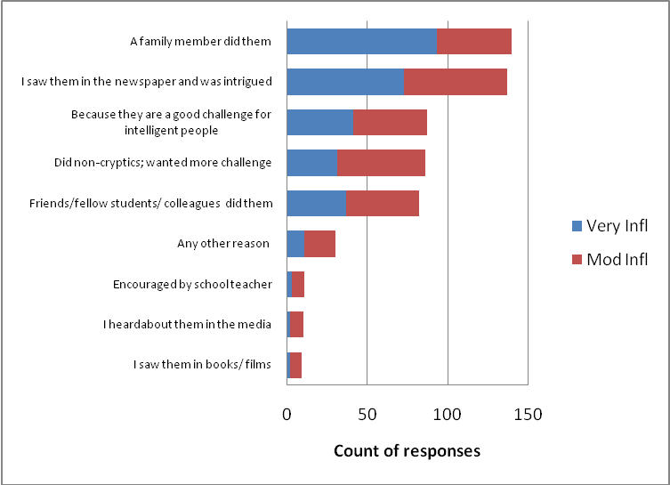

Figure 1: Reasons for starting to solve cryptics (count of responses)

How did you learn to solve cryptics?
Respondents were invited to indicate which method(s), from a pre-defined list, they used in learning how to solve cryptics, and whether they were highly or moderately influential. Again, many respondents learned to solve crosswords in the days before solving manuals became available. Most respondents report, therefore, that they were largely self-taught (they worked out the method for themselves, or looked up the answers next day and worked backwards from this etc); and/or learned from parents/relatives:

Method of Learning | Very Infl | Mod Infl | Total | %
Trial & Error (looked up answers/worked it out) | 76 | 125 | 201 | 43%
Taught by Parents/Relatives | 53 | 65 | 118 | 25%
Self-help Manual/Newspaper articles | 43 | 22 | 65 | 14%
Taught by Peers/Colleagues | 34 | 16 | 50 | 11%
On-Line Weblogs | 12 | 1 | 13 | 3%
Taught at School/Club | 11 | 2 | 13 | 3%
Any Other route | 2 | 4 | 6 | 1%
Went on a Course | 5 | 1 | 6 | 1%
Table 7: Method of learning to solve cryptics (Count of responses)
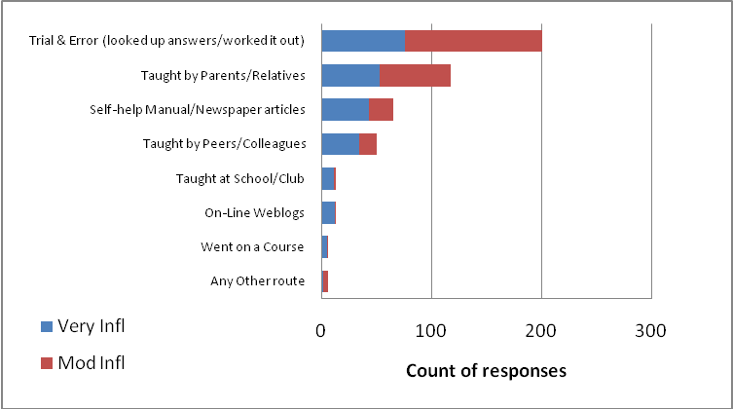

Figure 2: Method of learning to solve cryptics (Count of responses)

First (Block) Crossword Attempted
Respondents were asked to name the first block crossword they attempted when first starting to solve crosswords. As expected, many respondents started off with a slightly easier broadsheet crossword: the Daily Telegraph (whether in the printed newspaper or reprinted in the Pan ‘Cryptic Crosswords’ series) was particularly popular (32% of respondents named this as their first), but the Express, Daily Mail and Everyman (Observer) also featured widely (16% combined total). Local newspapers (such as the Nottingham Evening Post, Manchester Evening Post and Leicester Mercury) also played a part (11%). However, 38% of solvers started with the more challenging offerings in either the Times or the Guardian; and two respondents skipped the ‘block crosswords’ stage altogether, commencing with barred grid puzzles by Mephisto and Ximenes.

First Newspaper Attempted | Count | First Newspaper Attempted | Count
Daily Telegraph/(Pan Books) | 77 | New Yorker | 1
Times | 56 | Puzzler Magazine | 1
Guardian | 33 | Radio Times | 1
Everyman (Observer) | 14 | Sun | 1
Daily Mail | 13 | Sunday Times | 1
Local Newspapers | 11 | Sydney Morning Herald | 1
Express | 6 | Telegraph Saturday Prize Crossword | 1
Sunday Express | 5 | The Age (Australian broadsheet) | 1
News Chronicle | 3 | The Scotsman | 1
Glasgow Herald | 2 | The Week | 1
New York Magazine | 2 | Time and Tide | 1
Evening Post (NZ) | 1 | Ximenes (Observer) | 1
Independent | 1 | Total responses | 238
Irish News | 1 | Null returns | 3
Mephisto (Sunday Times) | 1 |  | 241
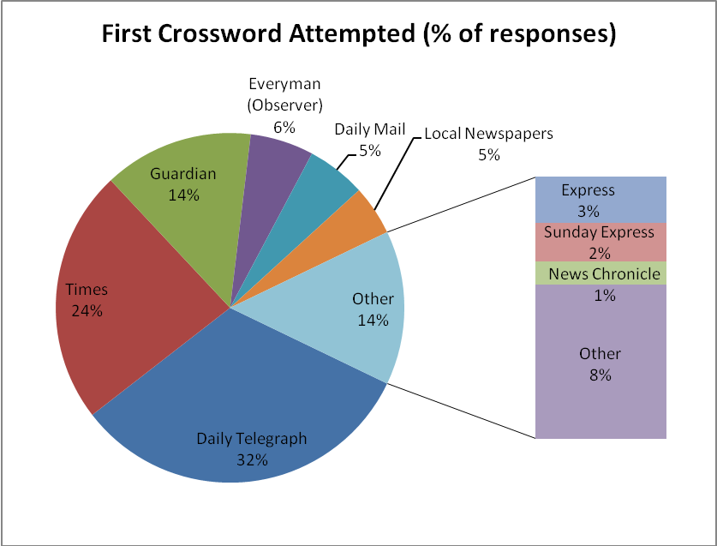
Table 9: First crossword attempted (count of responses)

Figure 3: First crossword attempted (% of responses)

Current Popularity of Crosswords among Expert Solvers
Respondents were asked to indicate which cryptic crossword(s) they now solved, and the frequency with which they solved them (Occasionally/Quite Often/Regularly). The results are given below; data is ranked in order of popularity of frequent solving (defined as the sum of ‘Quite Often’ or ‘Regularly’ responses only). ‘Advanced cryptic’ crosswords are highlighted in red.

Newspaper | Occasion-ally | Quite Often | Regularly | Total  ( all resps) | Total (Quite Often/Reg) | Rank
Listener (Times on Saturday) | 23 | 20 | 173 | 216 | 193 | 1
Times | 64 | 48 | 92 | 204 | 140 | 2
Times Saturday Crossword | 48 | 37 | 95 | 180 | 132 | 3
Azed (Observer) | 56 | 35 | 63 | 154 | 98 | 4
Bank Holiday/Christmas Jumbos (various papers) | 48 | 33 | 58 | 139 | 91 | 5
Saturday Times Jumbo | 69 | 21 | 51 | 141 | 72 | 6
Guardian | 75 | 21 | 48 | 144 | 69 | 7
Guardian Saturday Crossword/Alphabetical Jigsaws | 45 | 22 | 45 | 112 | 67 | 8
Inquisitor -Independent Mag  (Saturday: barred) | 38 | 20 | 41 | 99 | 61 | 9
Magpie | 23 | 12 | 49 | 84 | 61 | 9
Enigmatic Variations (Sunday Telegraph) | 59 | 24 | 34 | 117 | 58 | 11
Crossword Centre Monthly puzzle | 48 | 20 | 37 | 105 | 57 | 12
'Crossword' (Crossword Club) | 16 | 9 | 45 | 70 | 54 | 13
Spectator | 33 | 16 | 34 | 83 | 50 | 14
Mephisto (Sunday Times) | 56 | 19 | 27 | 102 | 46 | 15
Private Eye | 36 | 17 | 25 | 78 | 42 | 16
Independent Prize Crossword (Saturday: blocked) | 39 | 10 | 31 | 80 | 41 | 17
Independent | 75 | 19 | 21 | 115 | 40 | 18
Sunday Times | 32 | 8 | 26 | 66 | 34 | 19
Everyman (Observer) | 50 | 9 | 21 | 80 | 30 | 20
Daily Telegraph | 73 | 14 | 9 | 96 | 23 | 21
'Weekend FT' Prize Cryptic Crossword | 16 | 8 | 6 | 30 | 14 | 22
Beelzebub (Independent on Sunday) | 35 | 6 | 7 | 48 | 13 | 23
Financial Times | 51 | 9 | 4 | 64 | 13 | 23
Independent on Sunday | 28 | 6 | 7 | 41 | 13 | 23
Sunday Telegraph | 16 | 6 | 7 | 29 | 13 | 23
One Across | 8 | 3 | 9 | 20 | 12 | 27
Telegraph Saturday Prize Crossword | 26 | 3 | 9 | 38 | 12 | 27
Radio Times | 17 | 2 | 7 | 26 | 9 | 29
Atlantic Monthly | 9 | 3 | 4 | 16 | 7 | 30
Express | 10 | 1 | 2 | 13 | 3 | 31
Oxford Today |  |  | 3 | 3 | 3 | 31
Sunday Express | 9 | 1 | 2 | 12 | 3 | 31
The Oldie |  |  | 2 | 2 | 2 | 34
The Week |  | 1 | 1 | 2 | 2 | 34
CAMRA Magazine |  |  | 1 | 1 | 1 | 36
Daily Mail |  | 1 |  | 1 | 1 | 36
Enigma (National Puzzlers' League) US |  |  | 1 | 1 | 1 | 36
Enigmatist.com |  | 1 |  | 1 | 1 | 36
Glasgow Herald |  |  | 1 | 1 | 1 | 36
Guardian Genius |  |  | 1 | 1 | 1 | 36
Harpers | 1 |  | 1 | 2 | 1 | 36
Literary Review |  |  | 1 | 1 | 1 | 36
Local Newspapers |  |  | 1 | 1 | 1 | 36
Mail on Sunday |  |  | 1 | 1 | 1 | 36
New Statesman | 12 |  | 1 | 13 | 1 | 36
New York Magazine |  |  | 1 | 1 | 1 | 36
SAGA Magazine |  |  | 1 | 1 | 1 | 36
TableAus (Australian MENSA) |  |  | 1 | 1 | 1 | 36
Toronto Globe and Mail |  |  | 1 | 1 | 1 | 36
Irish Times (Croisaire) | 1 |  |  | 1 | 0 | 51
The Scotsman | 1 |  |  | 1 | 0 | 51
Table 10: Crosswords tackled by respondents (Count of responses)
As predicted, expert solvers had generally migrated to more challenging crosswords. The Everyman and the Daily Telegraph (though this was prior to the introduction of the Telegraph ‘Toughie’) slipped to 20th and 21st in the rankings; and the advanced cryptic crosswords were very popular, filling many of the top places. The domination of the Listener crossword is very apparent among advanced cryptics, as is the Times newspaper among the daily blocked grids (although the Guardian has a loyal following and attracts a large ‘occasional’ audience). ‘Jumbos’ are still popular, however, perhaps providing a welcome and easier challenge at holiday times and weekends.
Solvers were also tackling multiple crosswords, and from a wide range of publications. The mean number of crosswords tackled ‘Regularly’ was 4.5; the median was 3 and the maximum 28.

Educational Background
Respondents were highly educated, with 195 respondents holding a degree or further degree (81%).
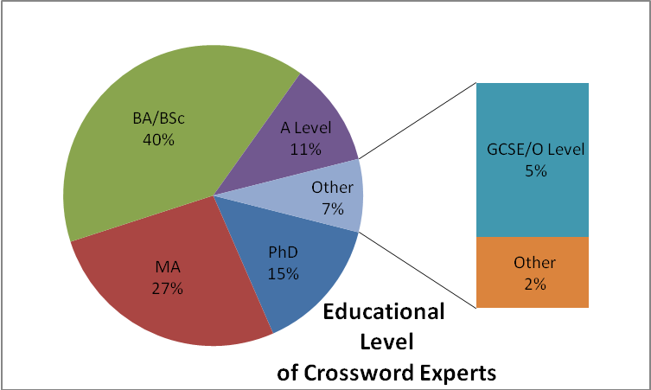

Figure 4: Educational level of Crossword Experts (% of responses)

Respondents were asked to indicate their main subject studied at school/university. These were then categorised into broad areas, and revealed a pronounced bias towards mathematics, economics, finance and science. Numbers shaded in green add up to 152 (63% of the total response).

Main Subject Field | No. Respondents
English | 14
Mod. Languages | 32
Medicine | 11
Science | 45
Mathematics | 63
Stats/Economics | 17
Accountancy/IT | 6
Engineering | 7
Bus Studies | 3
Classics | 10
Law | 6
Archaeol/ History | 7
Other (art, music, politics, journalism etc) | 20
 | 241
Table 11: Main subject studied (Count of responses)

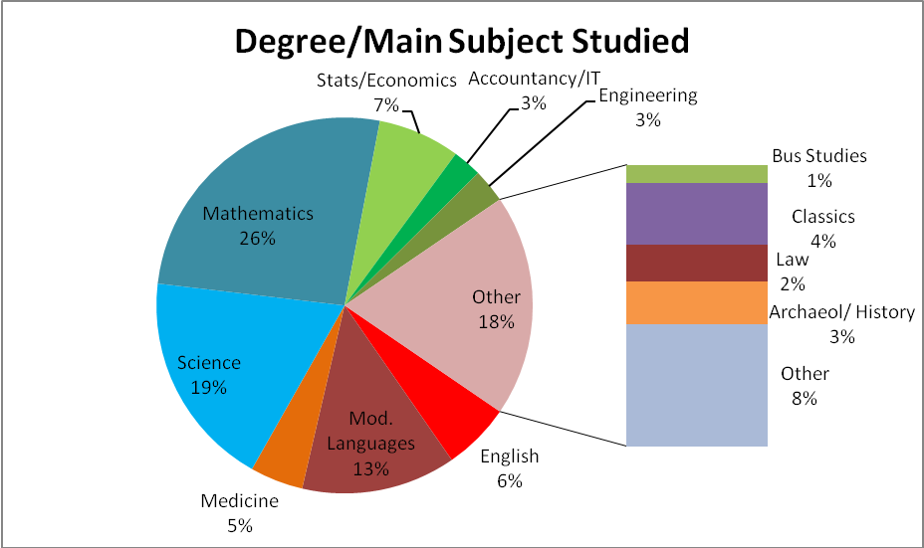

Figure 5: Degree/ Main Subject studied (% of responses)

This may support the hypothesis that the attraction of cryptic crosswords lies as much in the code-breaking (quasi-algebraic) nature of the puzzles as in the linguistic demands they pose.

Occupation of Crossword Experts during Working Life
Respondents were asked to provide details of their main occupation during their working life. Once again these details were categorised into broad fields.

Occupation data was particularly difficult to analyse. Some participants had followed a number of different careers, and a judgment was made as to which should be considered the primary occupation. Some jobs straddled sectors; again a judgment had to be made. (All teaching and lecturing was assigned to the area of teaching speciality.) The following data should therefore be treated with some caution; but in general the pattern of heavy bias towards the scientific/mathematical/IT/accountancy fields is clear (green shaded items form 64% of the total):
Occupation | No of Resps | %
Admin/Civil Serv/Management | 32 | 13
Creative/Media | 25 | 10
Languages | 10 | 4
IT | 70 | 29
Mathematics | 14 | 6
Banking/Fin/Accts | 23 | 10
Actuarial/Stats/ Economics | 15 | 6
Medicine | 12 | 5
Scientist | 20 | 8
Business/ Consult | 4 | 2
Investig/Legal | 3 | 1
Engineering/Construct | 3 | 1
Farming/Manual | 3 | 1
Other | 7 | 3
 | 241
Table 12: Occupation of experts (count of responses)
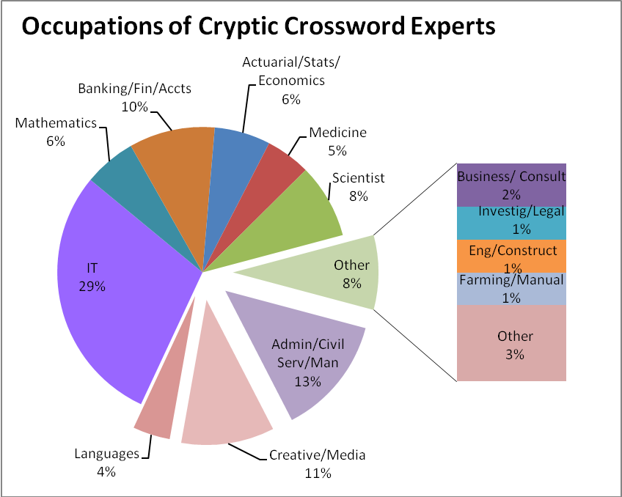

Figure 6: Occupation of experts (% of responses)

The numbers of respondents engaged in IT are particularly striking: it has been suggested that some skills and aptitudes required for programming are equally useful for cryptic crossword solving (Simon, 2004).

Acknowledgments
Many thanks to John Green for helping us to advertise the survey with the annual Listener statistics, Peter Biddlecombe for advertising it at the Times speed-solving competition and Derek Harrison for allowing us to advertise it on The Crossword Centre’s message board.

Thanks also to the pilot study members for their invaluable comments and suggestions; to Chris Lancaster for the copy of his earlier survey of Crossword Centre members (Lancaster, 2005); and to John de Cuevas for a copy of his study of PuzzleCrypt members in the USA (de Cuevas, 2004).

Address for correspondence
Dr. Kathryn Friedlander, Department of Psychology, University of Buckingham, Hunter St., Buckingham, MK18 1EG, UK; Email: kathryn.friedlander@buckingham.ac.uk

Bibliography
CHASE, W. & SIMON, H. A. (1973) Perception in Chess. Cognitive Psychology, 4 55-81.
DE CUEVAS, J. (2004 website) Survey of PuzzleCrypt.com Members, accessed at http://www.puzzlecrypt.com/surres04.pdf.
DE GROOT (1965) Thought and choice in chess, The Hague: Mouton Publishers
FRIEDLANDER, K. J. & FINE, P. (2009) Expertise in cryptic crossword performance: An exploratory survey presented at the International Symposium on Performance Science, in Auckland, NZ.
GOBET, F. & CAMPITELLI, G. (2007) The role of domain-specific practice, handedness, and starting age in chess. Dev Psychol, 43 1, 159-72
LANCASTER, C. (2005 website) The Survey of Crossword Centre Subscribers, accessed at http://www.crossword.org.uk/Survey.pdf.
SIMON (2004) The cryptic crossword puzzle as a useful analogue in teaching programming. ACM International Conference Proceeding Series, 57 299-303.
SLOBODA, J. A., DAVIDSON, J. W., HOWE, M. J. A. & MOORE, D. G. (1996) The role of practice in the development of performing musicians. British Journal of Psychology, 87 2, 287-310.
WATERS, A. J. & UNDERWOOD, G. (1998) Eye movements in a simple music reading task: A study of expert and novice musicians. Psychology of Music, 26 (1), 46-60.

The material for the introductory sections of this paper have been taken, with slight modification, from a presentation on crossword expertise given by the authors in Auckland, NZ in Dec 2009 (Friedlander & Fine 2009).
See, for example, the analysis of the more popular UK newspaper and magazine cryptic crosswords by Peter Biddlecombe, at http://www.biddlecombe.demon.co.uk/yagcc/YAGCC5.html
For example in the Independent on Saturdays (Inquisitor), The Spectator magazine and in the Sunday Telegraph (Enigmatic Variations).
The Listener Crossword is published each Saturday in the Times newspaper. Solvers are invited to submit competition entries, which are then compiled for the official annual statistics (personal and general) by John Green. Very few entrants achieve an ‘all-correct’ year (14 in 2006, 21 in 2007, 32 (a record) in 2008; those submitting 42+ appear on a roll of honour. Total numbers of individuals submitting entries in each year range from between 1500-3300). See further the official Listener site www.listenercrossword.com
As confirmed by Derek Harrison, website owner, e-mail dated 18/9/09
Sandy Balfour ‘The Last Word’ (on the retirement of the setter Ruth Crisp), The Guardian, Monday 6 December 2004
Data supplied by Chris Lear, Magpie editorial team member, e-mail dated 25/9/09.
The survey was launched before the introduction of the Telegraph ‘Toughie’ (in Sept 2008) – which claims to be one of the toughest cryptics on Fleet Street. This may possibly now attract a greater number of crossword experts to the title.
The New Statesman was erroneously included as an option in the survey, as the magazine had ceased to publish a cryptic crossword at that time (though this decision has now been reversed for 2010). Some of those indicating that they ‘occasionally’ solved the crossword clarified in the notes that they had previously solved this crossword when it had been available.

